Lab 16 Set up Mongo Environment

LIS 464

Information School, University of Wisconsin-Madison

**Deliverables:** A word document with one item.

1. screenshot of “sample_airbnb” for submission showing you have set up your Mongo account and loaded the sample data.

**Description**: This lab allows you to practice how to sign up with a free Mongo Atlas account, tour Atlas interface, and go over major interface elements we will use to upload JSON documents and run queries.

# **Task 1: Watch Someone Else Do it First:**

This lab is based on a MongoDB YouTube tutorial. You should watch the 9 minute video tutorial before beginning the process of setting up your account, or you may watch it as you set up your account, pausing along the way. <https://youtu.be/xrc7dIO_tXk>

# **Task 2: Sign Up for Your Mongo Account:**

Step 1: Go to ​​<https://www.mongodb.com/> and click ‘’try free’’ to create a account

Step2 : Choose the create free account option

Step3: Select ‘’Google Cloud’’ and a location in the US. I suggest Iowa, but it should not matter.

# 

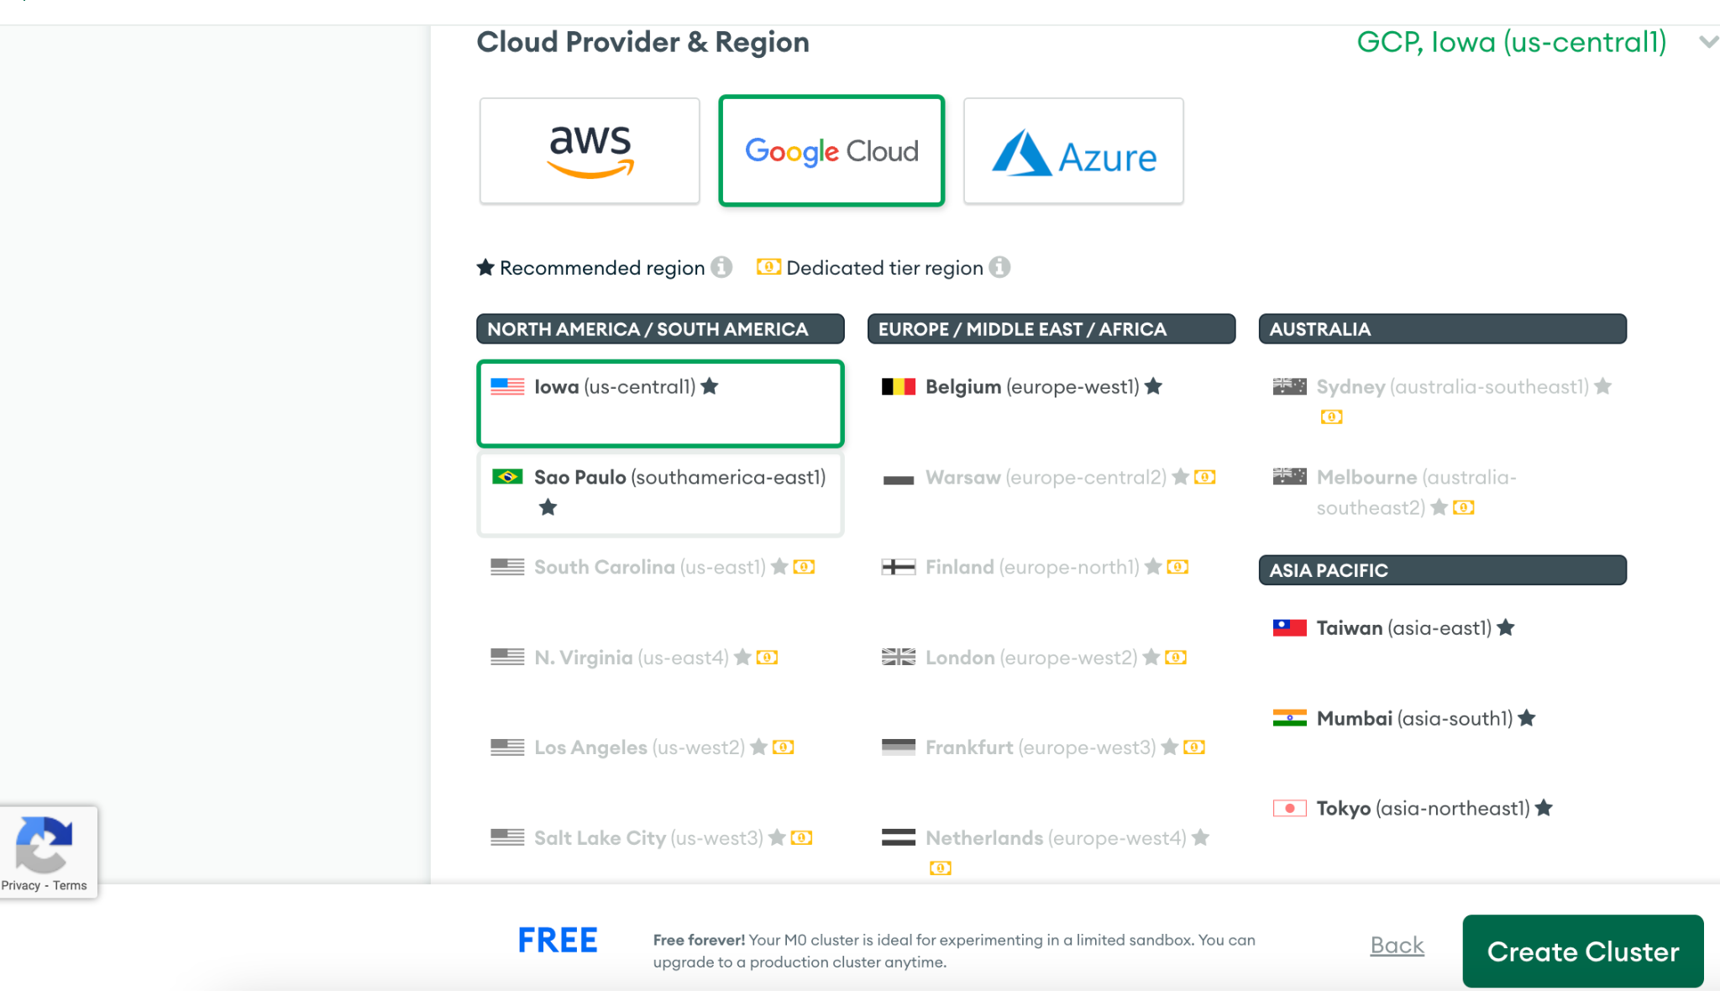

Step 4 : Create the user name and password for the connection. Write down your username and password as you will need it in the future.

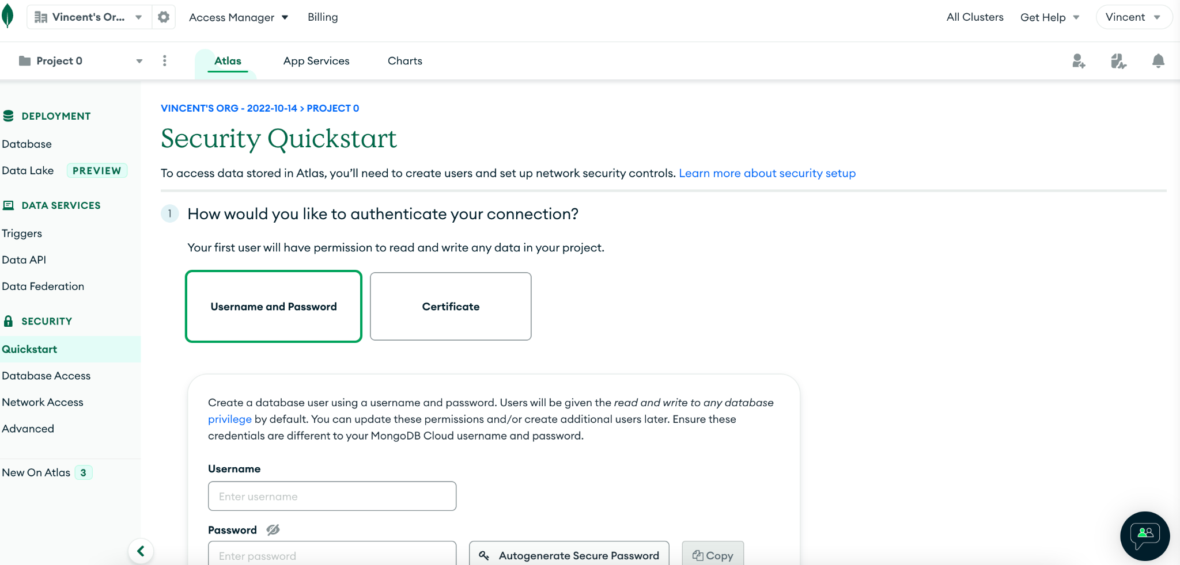

Step 5 : Click button “Add your current IP address” For grading purposes, please be sure your database is set to allow connection from any IP address

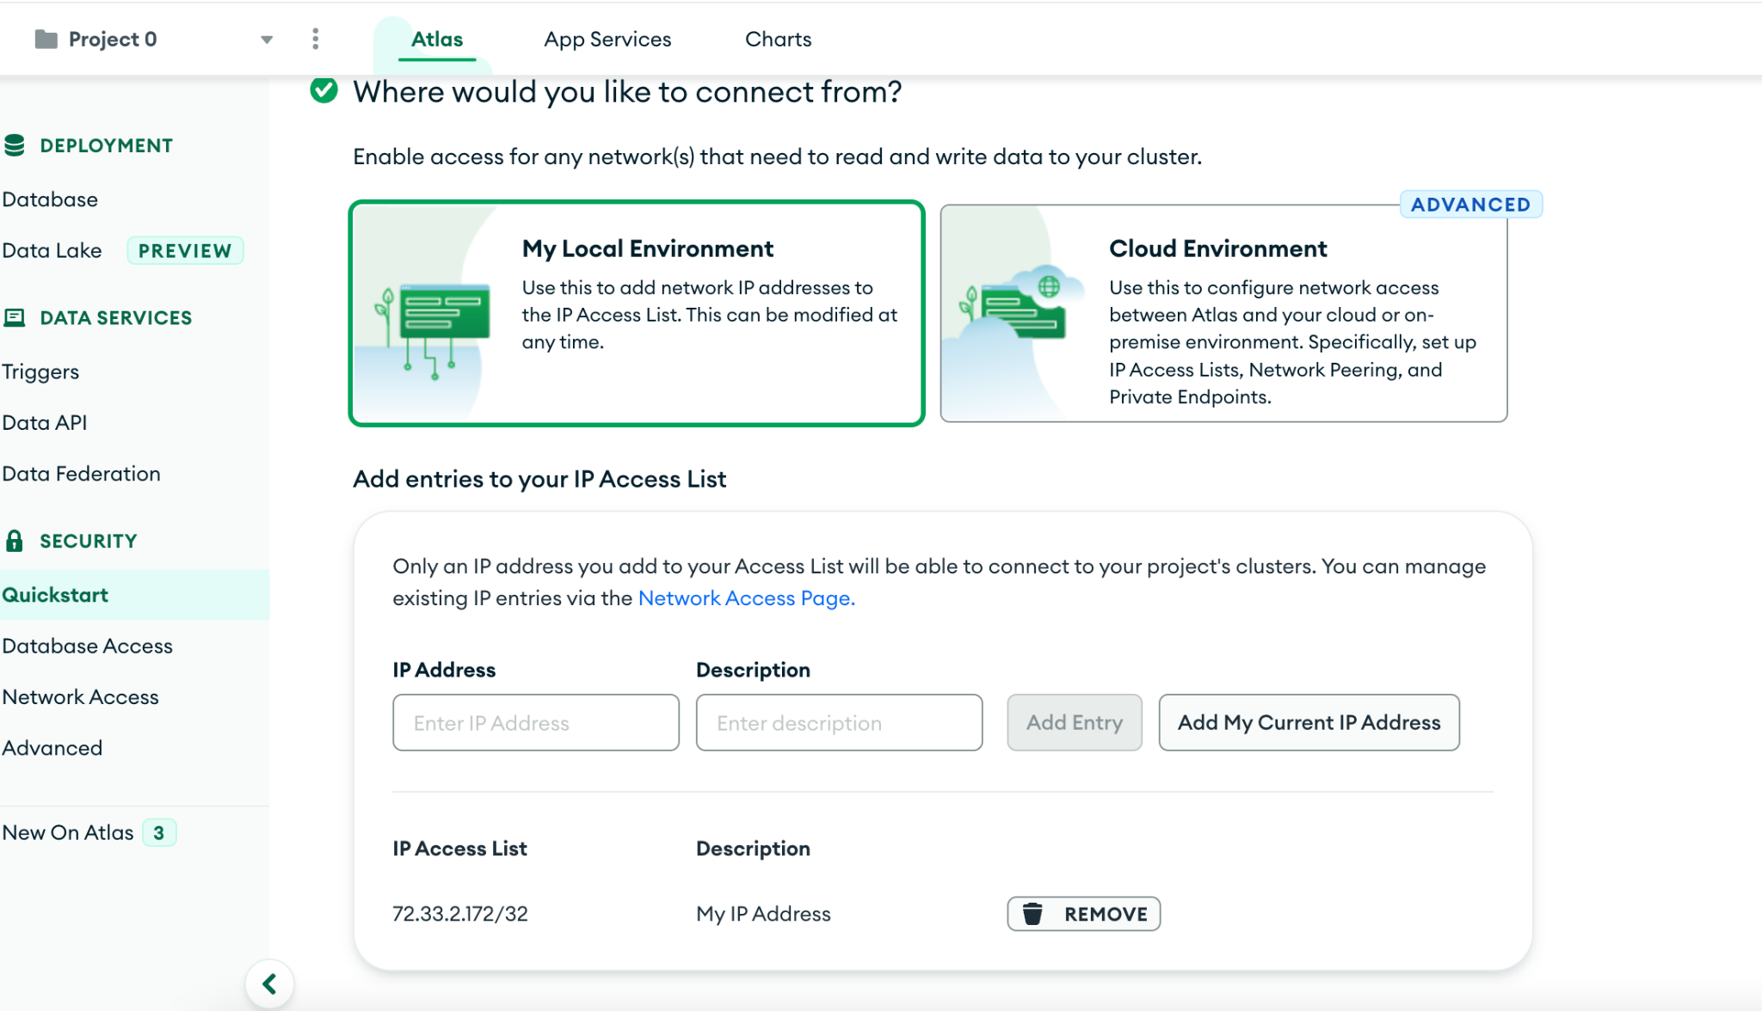

Step 6: Make sure you can get to this page.

You won’t have any databases yet.

# **Task 3: Load Datasets into MongoDB Atlas**

Step 2.1: From the cluster view in the Atlas management console, click on the ellipsis button [...] and select “Load Sample Data” from the menu. Then confirm your selection. *Are you lost? Go back and watch the video in Task 1.*

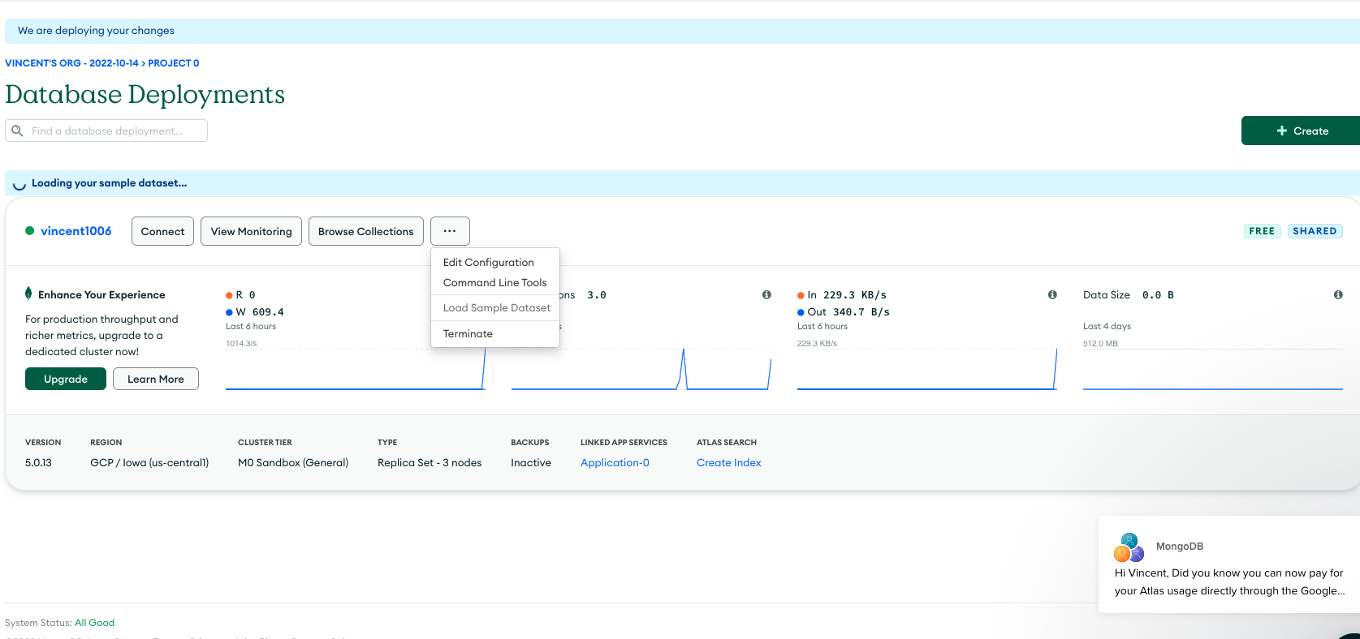

Step 2.2: This will load a few sample collections that you can use to run test queries and learn more about MongoDB. You can view the sample collections loaded by clicking on the Collections button on your cluster from the Clusters tab in Atlas.

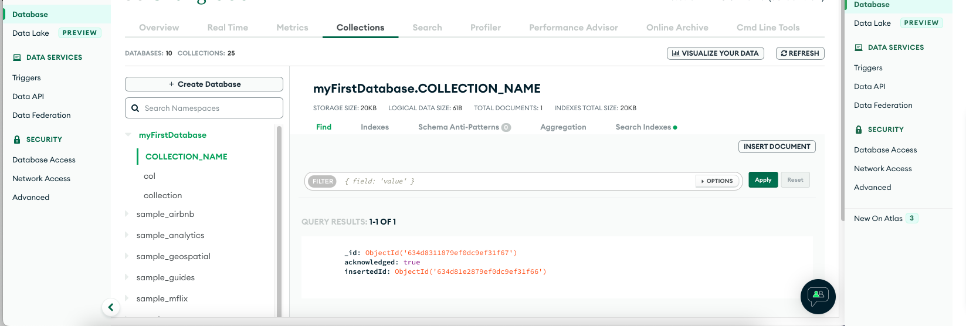

Step 3: Take a screenshot of some data from the “sample_airbnb” database to prove that you have connected and loaded the sample databases.

Save the screenshot of “sample_airbnb” for submission.